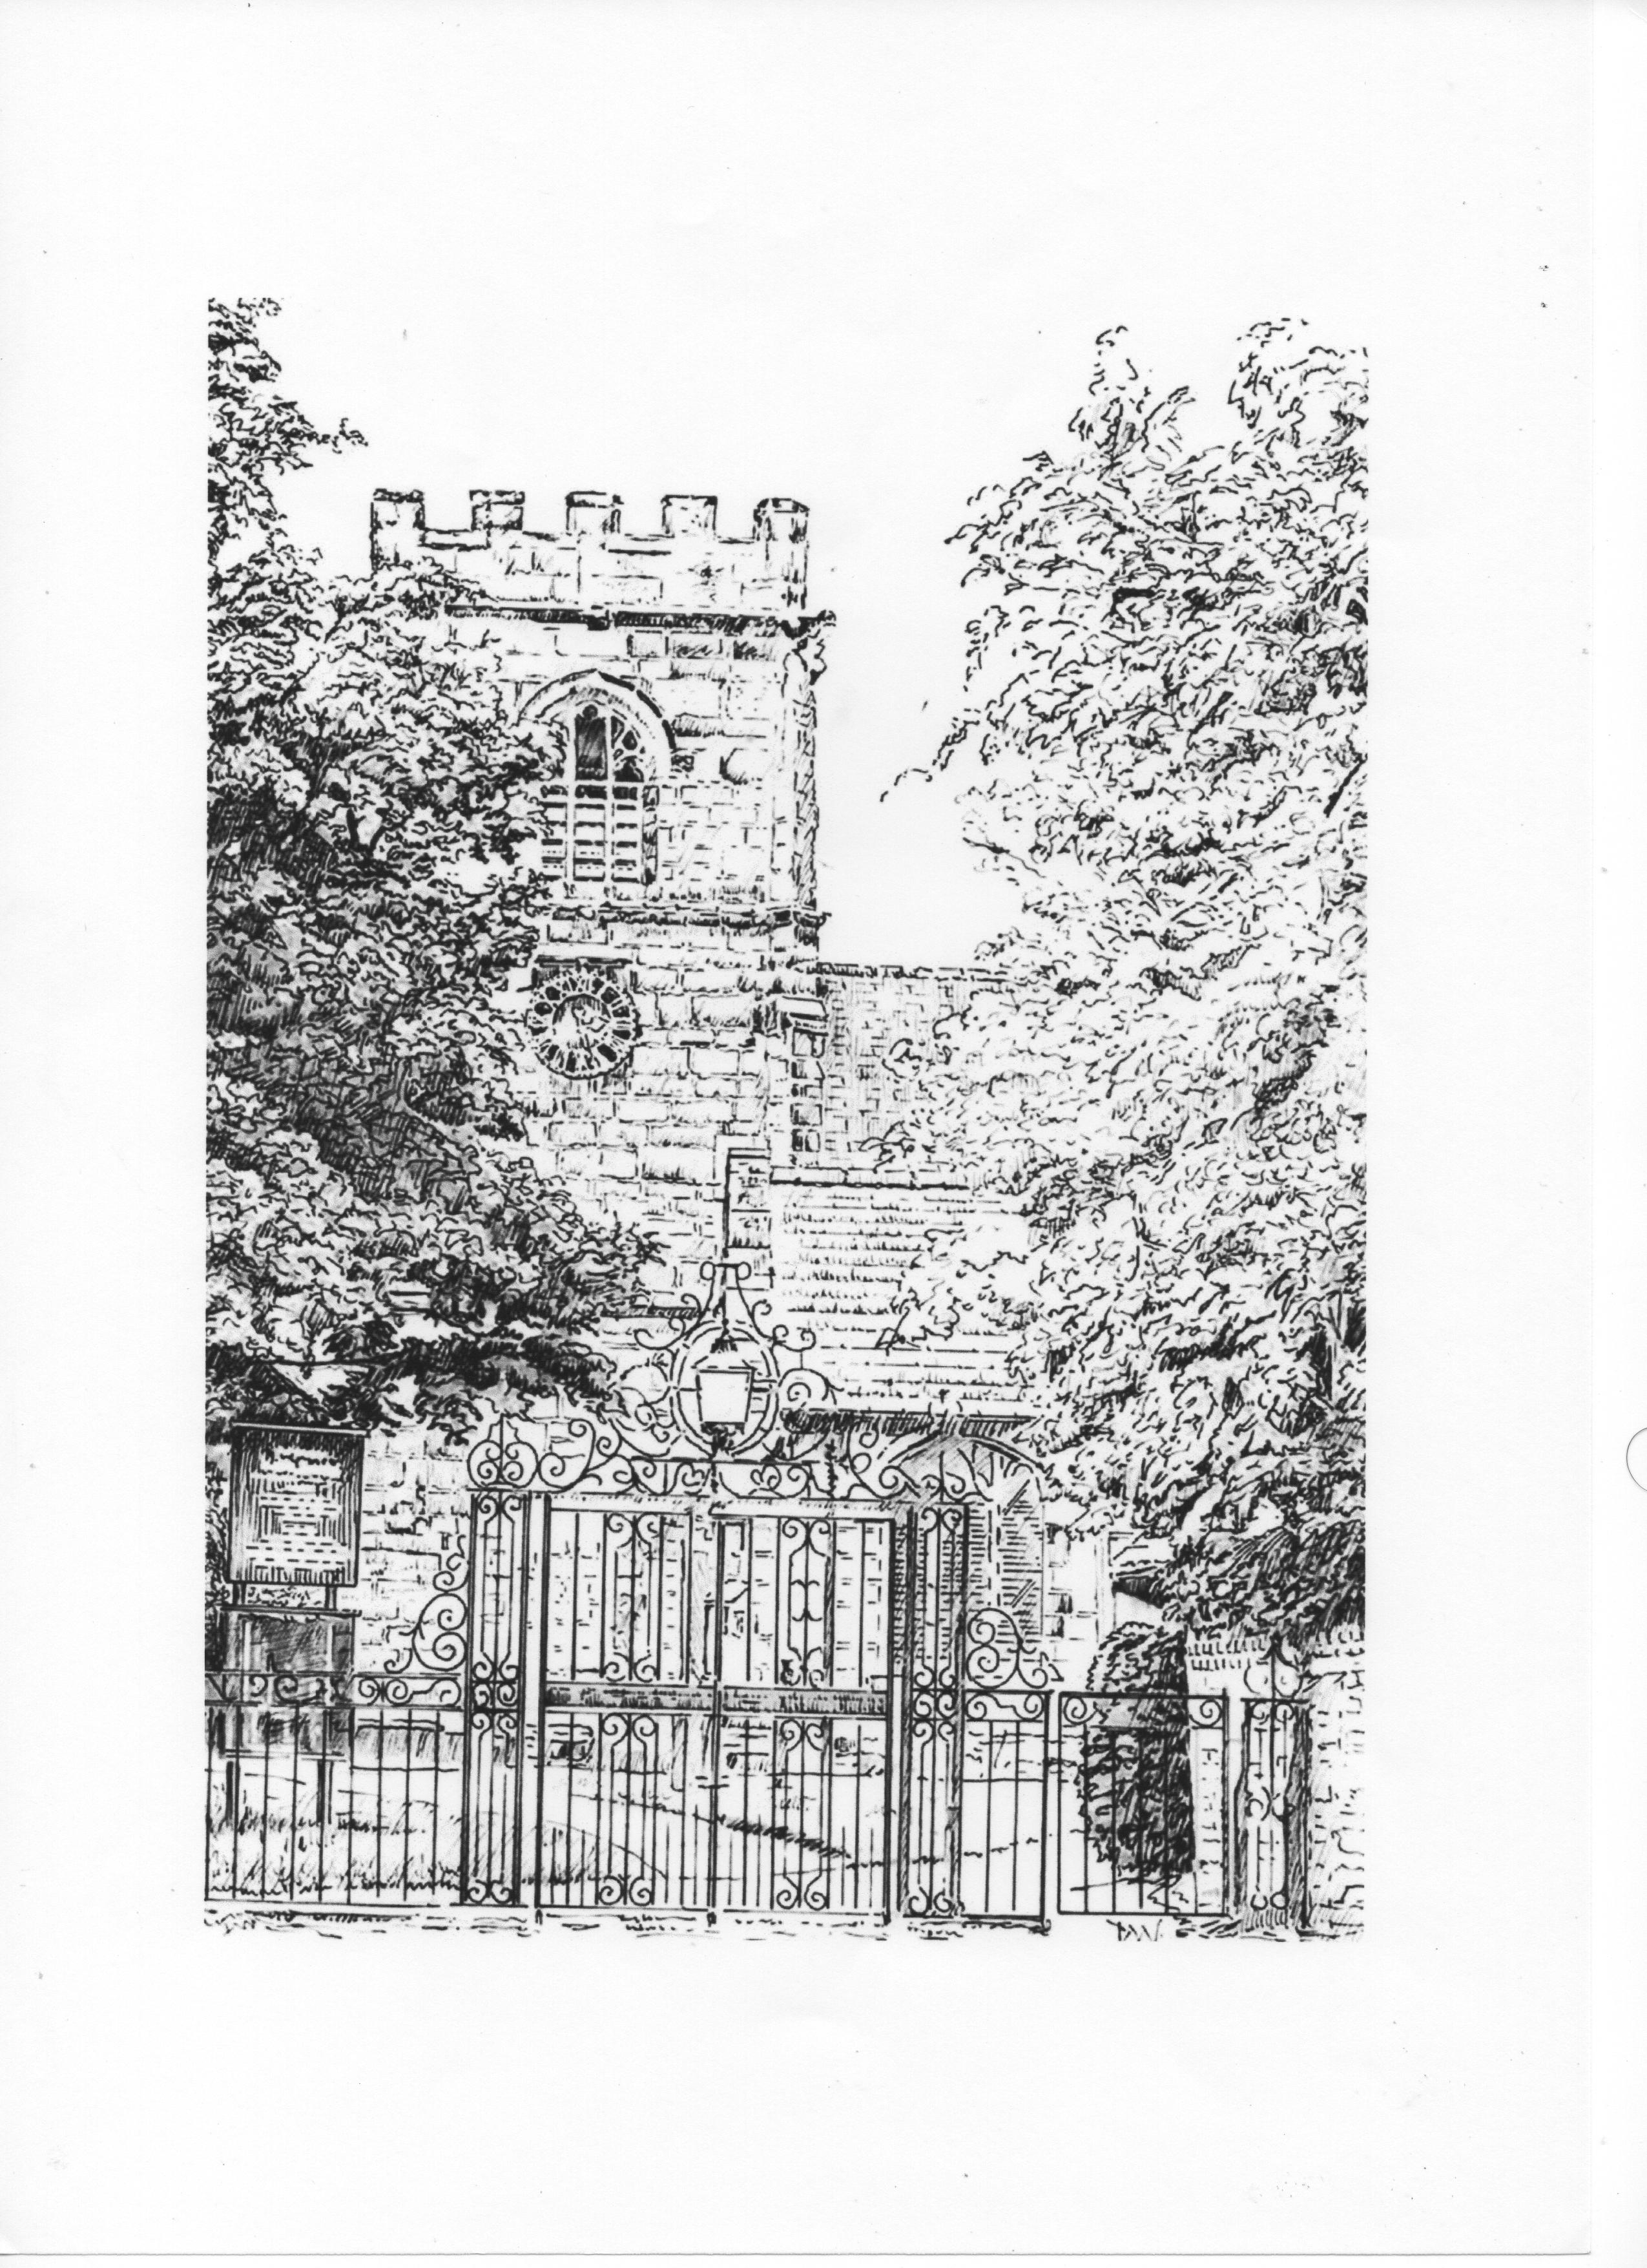ST. ALBAN’S CHURCH, TATTENHALL
www.tattenhallchurch.co.uk

APPLICATION FOR BAPTISM
Notice of at least 2 weeks should be given before a child is brought to the church for baptism

PLEASE COMPLETE THIS FORM IN BLOCK CAPITALS

CHRISTIAN NAMES AND SURNAME OF CHILD/CANDIDATE ____________________________________________________
ADDRESS _____________________________________________
____________________________________________________
PHONE NUMBER ________________________________________
DATE OF BIRTH OF CHILD/CANDIDATE __________________
Baptised? Confirmed?
FATHER’S FULL NAME ___________________________
MOTHER’S FULL NAME ___________________________
ADDRESS AND PHONE NUMBER IF DIFFERENT FROM ABOVE ____________________________________________________
OCCUPATION OF PARENTS FATHER _______________________
MOTHER ______________________
NAMES OF GODPARENTS Baptised? Confirmed?
- _______________________________________

- _______________________________________

- _______________________________________

PREFERRED DATE FOR BAPTISM _____________________________

CHOICE OF BAPTISM HYMN __________________________________________
(Only available if Baptism to be at 10.30am Sunday service)

APPROX HOW MANY INVITED GUESTS ARE YOU EXPECTING? ____________

Important:- please read notes overleaf

As a parent or godparent you should ask yourself:
- Are you prepared to the best of your ability to give the child a Christian upbringing within the family of Christ’s church?
- Will you help the child to be regular in public worship and in prayer, not only by your teaching but also by your example and your prayers?
- Will you encourage the child in due time to come to Confirmation and Communion?

It is not essential for parents to be baptised and confirmed unless they are to be godparents.
Church Law requires that godparents should be baptised and confirmed, but the requirement of confirmation can be relaxed.

The usual time for baptism is at the 10.30am service on Sunday morning – preferably on the 1st or 3rd Sunday of the month or on a Saturday, by special arrangement.

Please return this form to the Rector at least two weeks before the day of baptism.

Whilst there is not a charge for Baptism, we would very much appreciate a contribution towards the running costs of our church.
If you would like to give a donation (in an envelope please), please pass to the churchwardens on the Baptism day.

Our flower ladies are happy to arrange flowers for the font for a small fee. Please indicate if you would like further details.

We look forward to meeting you!

